RESOLUTION NO.__________

RE: CERTIFICATE OF APPROPRIATENESS UNDER THE
PROVISIONS OF THE ACT OF THE PENNSYLVANIA
LEGISLATURE 1961, JUNE 13, P.L. 282 (53
SECTION 8004) AND BETHLEHEM ORDINANCE NO.
3952 AS AMENDED.

WHEREAS, it is proposed to install signs at 127-129 E. Third Street.

NOW, THEREFORE, BE IT RESOLVED by the Council of the City of Bethlehem that a Certificate of Appropriateness is hereby granted for the work.

Sponsored by: (s)

(s)

ADOPTED BY COUNCIL THIS DAY OF

(s)
President of Council

ATTEST:

(s)
City Clerk

HISTORIC CONSERVATION COMMISSION

CASE # 580– It is proposed to install signs at 127-129 E. Third Street
OWNER/APPLICANT: East Allen Venture, LLC/ Joseph Pearl, Jr

The Commission upon motion by Mr. Cornish seconded by Ms. Starbuck adopted the proposal that City Council issue a Certificate of Appropriateness for the proposed work described herein:
- The proposal to install signs at 127-129 E. Third Street was presented by Bill Eaton.

- A (14’-6”) long wall sign will be installed front of the building and will read “George’s Light Lunch and Deli” with a logo. It will have ½” thick black acrylic lettering pin mounted ½”-1” off the facade. The main lettering will be 13.25” high and the byline will be 4.75” high.

- The proposed blade sign will be 18” high x 24” wide with black lettering on an off-white background. The shape of the sign will be a rectangular. The sign will hang from a black scroll sign bracket.

- A vinyl window sign will be installed on the front window. The sign will be located in the center of the display window and will be off-white as presented at the meeting.

- No lighting was approved at this time.

- Hours for the front door must be submitted in the future for HCC review.
- The proposed motion was unanimously approved.

CU: cu
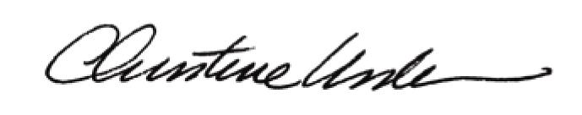

By:

Date of Meeting: February 22, 2016 Title: Historic Officer

